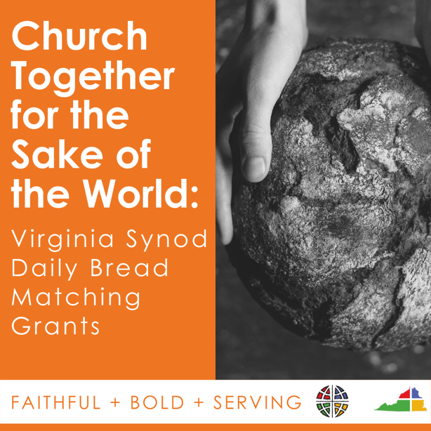
Video Script

Today I want to share some exciting news with you. (Insert Congregation Name) just found out that we have received a $250 Daily Bread matching grant from the Virginia Synod to help support (Insert Name of Feeding Ministry). We have until July 15 to raise $250 and receive the match. With your help, we can make our goal and provide food to even more people in our community.

You can make a gift by going to (insert website info) to make your gift. I’ve also put the link in the comments below.

Thank you for helping fight food insecurity in (Insert Community Name). Thank you for helping us be church together for the sake of the world. Your generosity makes a difference!

